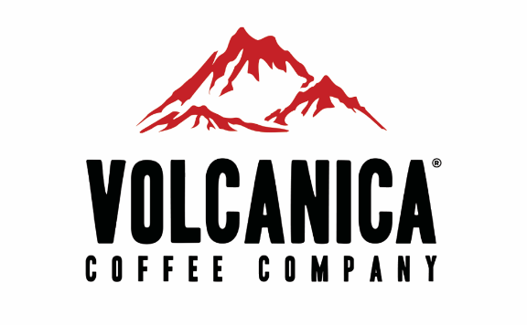
Contact: Aaron Contreras
Managing Partner
Volcanica Coffee Company
(954) 531-9244
aaron@volcanicacoffee.com

FOR IMMEDIATE RELEASE
December 09, 2019

Volcanica Coffee Partners with DK Metcalf, of the Seattle Seahawks, to create a Decaf Coffee after Announcer Mispronounces Dk’s Name

ATLANTA (December 9, 2019) – Volcanica Coffee, a gourmet coffee company, partners with DK Metcalf, of the Seattle Seahawks, after ESPN announcer, Joe Tessitore, mistakenly called DK “Decaf Metcalf” during the December 2 game.

Volcanica’s new Decaf Metcalf coffee was inspired by the slip-up during the Seahawks v.s. Vikings Monday Night Football game. The Decaf Metcalf Coffee is a 16-ounce medium roast blend of decaf beans from Paupa New Guinea and Guatemala.

A portion of proceeds from this coffee is donated to the charities of DK and Tessitore’s choice. The charities chosen are the Cystic Fibrosis Foundation and Prison Fellowship.

"Tessitore has blessed the deal, with Metcalf,” an ESPN Insider said. “Tessitore is making sure part of the proceeds will be donated to charities of their choice.”

Many took to social media after the announcement of the partnership and demanded a caffeinated version of the Decaf Metcalf coffee.

“We created a caffeinated version of the Decaf Metcalf Coffee because of popular demand,” Aaron Contreras, Managing Partner at Volcanica said. “The Fullcaf Metcalf is now available on our website.”

To get more information on Volcanica Coffee’s new Decalf Metcalf and Fullcaf Metcalf coffees, visit our website.
###

About Volcanica Coffee
Volcanica Coffee, LLC is a specialty retailer of exotic gourmet coffee committed to offering only the finest quality from volcanic regions around the world that is wonderfully exotic and remarkable in taste. We carry over 120 different coffees including single origin, estate, peaberry, decaf and flavored coffees.

While the national coffee chains have recently elevated gourmet coffee there was still something missing and many people are still not aware that coffee can be an exotic experience. This became the reason behind starting the Volcanica Coffee Company in 2004, to focus on high quality single origin coffees which is now known in the coffee industry as the third wave of coffee

